EDAT PRACTICE 3 MAIN REPORT
ALEJANDRO SANTORUM & DAVID CABORNERO

Here is the main report of EDAT final practice, where we comment the programming decisions, troubles, overcomes and some observations about the practice.

First, coment that the programs/code is divided into the four parts that came in the assignment, so you should “cd” into them in order to compile+run those programs.
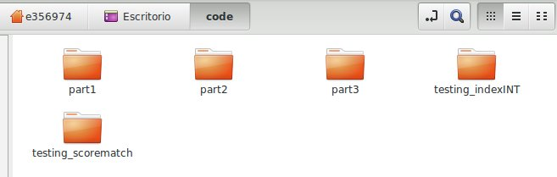

Coming up next, we comment them separately.

PART1 : File Management (folder part1):

In this part we have implemented the Table DAT, which simulates a SQL table in a binary file. You can check our functions by just opening table.c in this folder.

Once it was finished, we have coded a little small program to check that our functions had been programmed correctly. It is called table_test.c and what it does is to creating a table, open it, insert some records, close the table, open it again, read all the records inserted before and print them.

Here we show the output of the test:
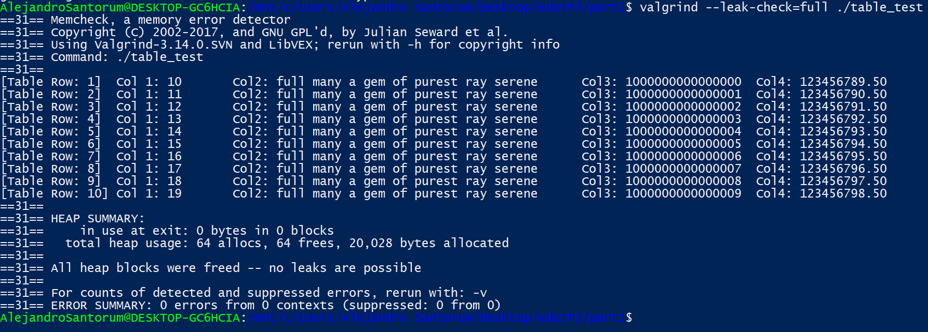
It is important to get noticed that we are showin the test with LLNG (long long integers) and DBL (double) types already implemented. Col1 is an int, Col2 is a string, Col3 is a long long number and Col4 is a double.
PART2 : Using local data (folder part2):

Here we want to use our functions of Table DAT to create a local table, that also is filled with some information of our old database using ODBC.

Comment that we have made some changes in our old database adding the field Book_id in our table Books in order to do what is specified in the assignment. So we also attach the files populate.sql and populate.txt that are modficied with the new implementation of our database.

In the program score.c you can give a score to a book and save it in your local table with this format: (ISBN: STR , title: STR , score: INT , book_id: INT). Moreover, in the program suggest.c you can ask for a suggestion: you give it a score and it reports a list of all books from authors that have obtained that score. Coming up soon, we are showing some outputs of theese programs as an example (as it is specified).
You can check the correct performance of our programs following the next steps:
1.- Create a database (to use later ODBC) using the commands in populate.sql or populate.txt and using the data files that we have privided in the folder “datos_libreria” as in the practice 2. Be careful with the \copy command, its functioning depends on the location of the “datos_libreria” folder.
2.- Once you hace created the database as we have specified, you can start running those programs by executing first create_table_file.c that creates a table file that is going to be used in score.c and suggest.c . We can´t create it in those programs, because each time you run them you would be creating a new table, and we don't want it because we would lose all the data. It is important to remark that you have to call it before doing anything or you will get a Fatal Error. Here is the implementation of create_table_file.c :
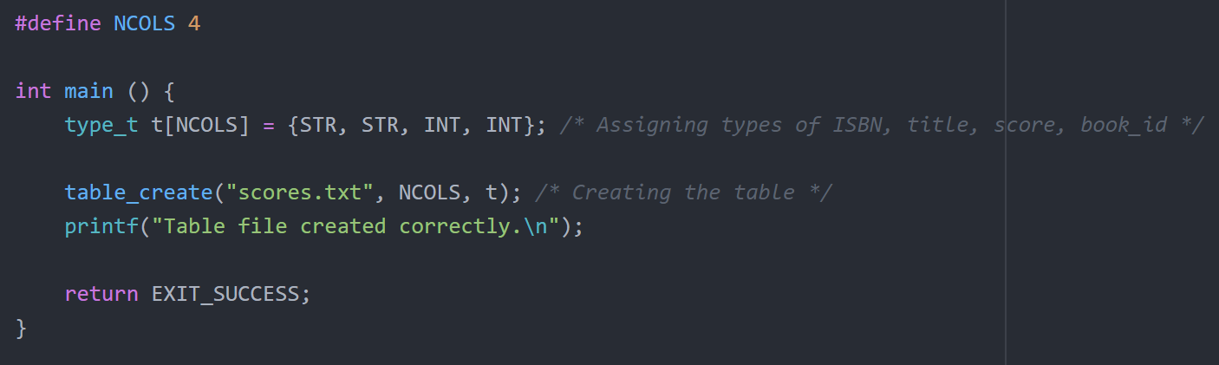
3.- Then, you can introduce some scores using ./score. This program just have to print “Everything went OK” “Score inserted successfully” if the program performanced correctly.
4.- Finally, you can run ./suggest as it is specified in the documentation and check its output. We don't let the program print twice the same author's books if he/she has two books with the same score in the local table.

Now, we show you the output examples as promised.

This is some outputs of score.c. You can check if you don't use first ./create_table_file it returns a Fatal Error. After executing this program, you can see the results of using ./score some books: “Who Rules the World?” with a score of 70, “Impossible Languages” with 70 and “MEDEA Y SU PERRO” with 40. In addiction we show the valgrind report, there are 0 errors but some memory is still reachable, this is because of odbc library that have some memory leaks (which isn't our fault).
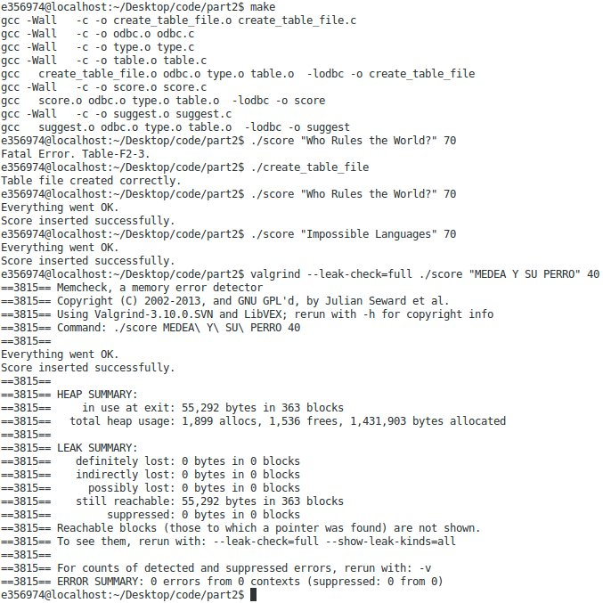

Here we show the result of asking for a suggest with score 70. Because of the fact we had introduced two books with the same score and distinct author we got printed the books of two authors.

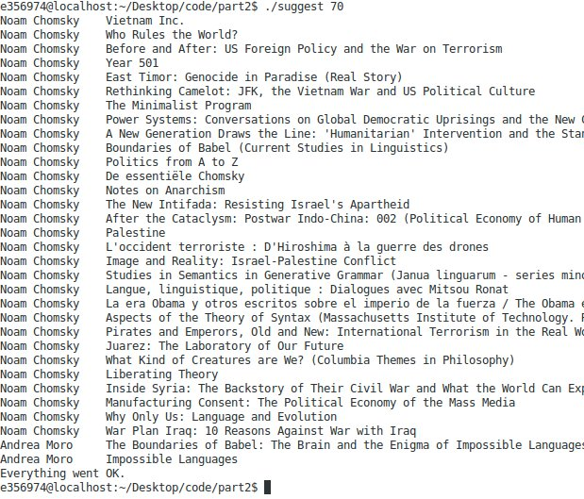

Down below there is a screenshoot of the same program but now with the valgrind report. Same comments that in the case of ./score
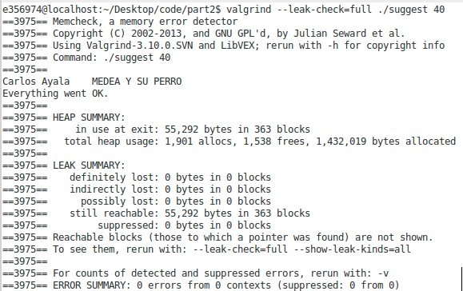
And thatś what you get when you ask for a score that is not in the local table.

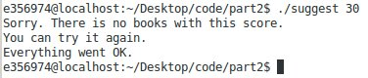

PART3 & PART4: More work & Optional (folder part3):

Here we want to develop the same two programs that we have done in the second part, but now we are helped by Index DAT, what makes, specially, suggest program way more efficient if our table of scores has a huge size.

So, our first goal is to program index.c with just type INT correctly. After finishsing it, we have tested this library with the program index_test.c which is placed in the folder “testing_indexINT”. You can try it out to corroborate its correct functioning.

Once we are sure that our functions are correctly, we modify our score.c and suggest.c of part2 with the new Index DAT. So now in score.c we have to introduce all the tuple in the table as we have done in the part2, but in addiction, we have to insert into an index the key-position of this tuple. We have decided to indexing by the score, becuase it is more useful than with the book_id. So, when we execute suggest.c, we use the index to get in just one interaction all the positions were the title & ISBN's books have the same score as the introduced one as an input parameter.

Of course we are showing next some screenshots with the outputs, but you can try iy by yourself following the next steps, very similiar to the part2:

1.- If you haven´t created our database as specified in part2.1 do it now as we have told.
2.- Just before trying to execute any program (score or suggest) you must run create_files.c, which is a small program that creates two files: one for the future table and another for the index. If you don't do it before score.c or suggest.c you will get a Fatal Error becuase the table/index is not created. Here is the implementation of create_files.c :
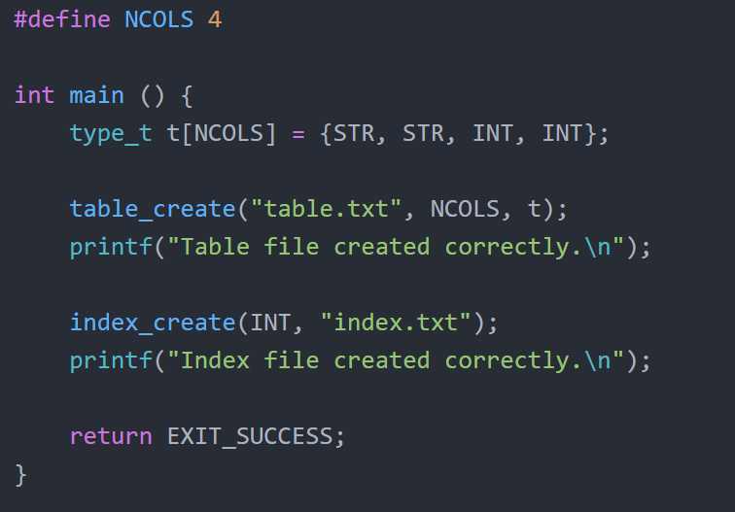
3.- Introduce scores as in part 2. You will get the same result if it went OK.
4.- Finally, you can run ./suggest and get the author-books pairs which its author has at least one book with the score specified as a input parameter.

Now, we show you the output examples as promised:

First, you can check what you get if you introduce a score that isn't registered yet:
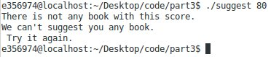

The second screenshot you find down below is the executioning of ./score of the part3 (using index and table at the same time). Remember that in this index there is already implemented the type STR as well as INT.

So, you can check what happens if you dont execute as soon as possible “create_files.c”, you will get a Fatal Error because those files doesn't exist. Once they are created we can continue to run ./score introducing some scores like “Impossible Language” with 60, “Who Rules the World?” with 60 and “MEDEA Y SU PERRO” with 30.

There is also attached a valgrind report, same comments than above.

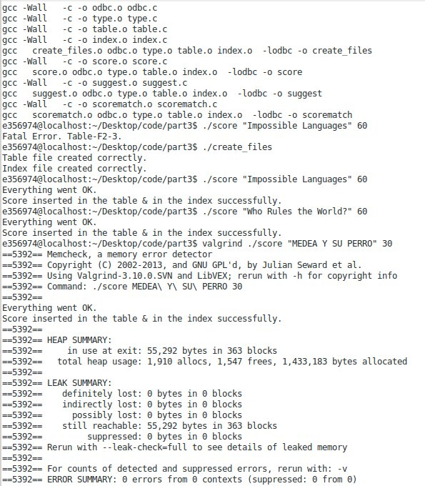

Last but not less important, we show you what happens if you introduce one score that is linked with only one book, with also a valgrind report.

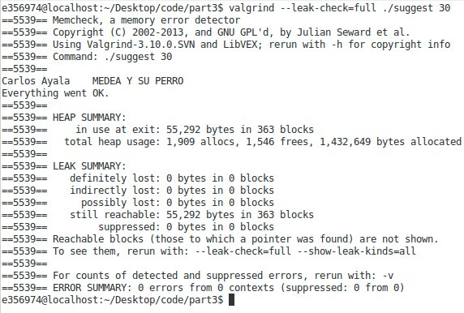

OPTIONAL PART:
In the same folder (part3) we have placed a program called scorematch.c which is the program in charge of testing the index.c with type STR. At this point you may have checked that our programs score.c and suggest.c of the part3 work correctly, and we want to highlight that those programs have been working using already the index.c STR/INT type. So if scorematch.c works correctly, he will have desmostrated that our index performaces well with STR type and INT type.

The program scorematch.c uses the table file created and filled in score.c to test STR index. It opens the table, opens the index, copies the information of the table into the index using as key the title, saves the index, closes it, opens it again, gets the positions associated with the title passed as an input parameters, takes its scores and searchs+prints all the books with theese scores.

You can test it in this folder perfectly after executing create_files.c + score.c . However, we give you another posibility: in the folder “testing_scorematch” you can find a testing program to STR index. The only change is that we have already provided you a file (called “table.txt”) with some information in it:
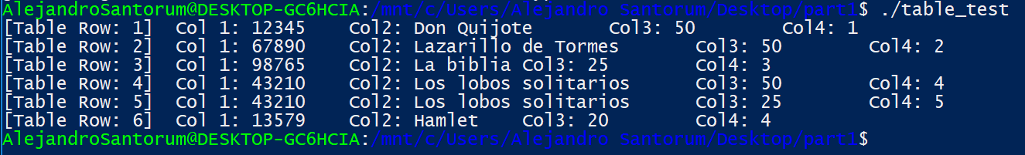

Here right below we show you some outputs of this selfmade testing program:
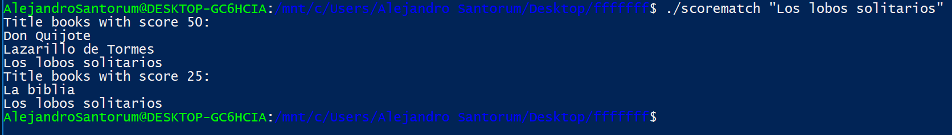
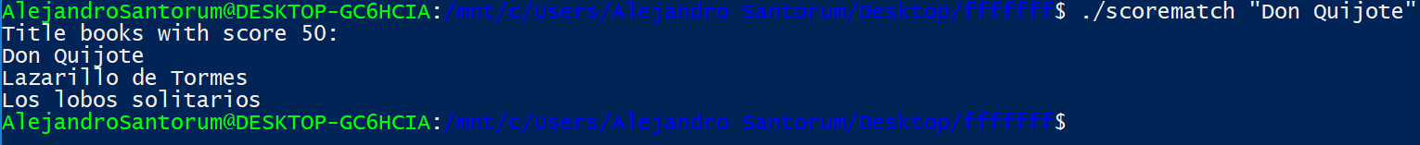
Finally, we also attach some output screenshots of scorematch.c in the folder part3 after using score.c:

The program uses the same file created by score.c, so itś important to have run it before.
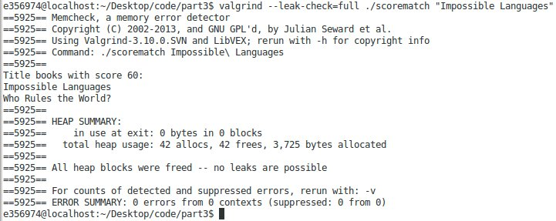

The valgrind report tells us there is no memory errors of any type.
NOTE: If one book appears twice with different score it will print both cases:
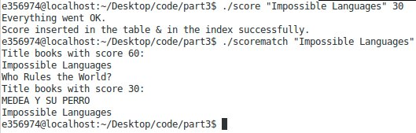
Finally, if you introduce a title that is not registered yet, you will get an error/warning that warns you it.

